Internship Project Report

Title: Supply Chain Management

Internship Domain: Data Analyst

Tools Used: Python, pandas, matplotlib, seaborn, scikit-learn, Jupyter Notebook

Submitted by – Ranjeet Singh

Content

- Introduction
- Exploratory Data Analysis
1. Sales by Product Type
2. Revenue by Shipping Carrier
3.SKU-Level Revenue and Order Quantities
4 Shipping Costs and Transportation Modes
5 Demand Distribution by Product and Location
6 Correlation Analysis
- Predictive Modeling
- Model setup
- Model Performance
- Feature Importance
4.Deployment
5.Business Strategy
6.Conclusion

Introduction
- Source: supply_chain_data.csv
- Size: 100 records × 24 features
- Scope: Covers product details, sales, logistics, manufacturing, inspection, and transportation costs.
- Cleanliness: No missing values or duplicates. Column names are standardized.
Exploratory Data Analysis (EDA)
1. Sales by Product Type
- Skincare leads with 20,731 units sold, followed by Haircare (13,611) and Cosmetics (11,757).
- Skincare dominates demand. Consider prioritizing inventory and marketing efforts here.
2. Revenue by Shipping Carrier
- Carrier B generates the highest revenue (~₹250K), followed by Carrier C and A.
- Carrier B may handle high-value shipments. Evaluate its cost-efficiency.
3. SKU-Level Revenue and Orders
- Line and bar charts show wide variation across SKUs.
- Some SKUs yield high revenue despite low order quantities—likely premium products.
4. Shipping Costs by Carrier
- Costs vary significantly across carriers.
- Carrier B is both costly and high-revenue. Consider optimizing contracts or routes.
5. Transportation Mode Costs
- Air transport incurs the highest costs.
- If not matched by revenue, consider shifting to Road or Rail where feasible.
6. Demand Distribution
- Boxplots show:
  - Skincare has high variability in sales.
  - Location-wise demand is uneven—Mumbai and Delhi show strong performance.
- Histogram reveals right-skewed distribution: few products dominate sales.
- Focus on top performers while investigating low-demand SKUs.
7. Correlation Heatmap
- Strong positive correlation between:
  - Revenue and Order Quantities
  - Price and Revenue
- Moderate correlation between Defect Rates and Manufacturing Lead Time.
- These relationships can guide feature selection for modeling.
Predictive Modeling
Objective: Predict "Number of products sold" using operational features.
Model Setup
- Algorithm: Random Forest Regressor
- Features Used:
  - Price, Availability, Order quantities, Stock levels
  - Lead times, Shipping costs, Production volumes
  - Manufacturing costs, Defect rates
Model Performance
Metric | Value
MAE | 310.46
RMSE | 354.84
R² Score | -0.32

Feature Importance
- Top predictors:
  - Order quantities
  - Availability
  - Price
- These features strongly influence demand. Consider refining them or engineering new ones (e.g., price tiers, product age).
Deployment
- Model saved using joblib for reuse.
- Ready for integration into dashboards or web apps.
Business Strategy
- Focus on high-performing SKUs and skincare category.
- Reassess shipping contracts, especially with Carrier B.
- Optimize transportation mode selection based on cost vs. revenue.

Conclusion
This project provided hands-on experience in data cleaning, visualization, and machine learning. It highlighted key supply chain inefficiencies and offered a foundation for predictive analytics. Future work will focus on improving model accuracy and integrating insights into decision-making tools.

Code with Output

#importing libraries
import pandas as pd
import numpy as np
import matplotlib.pyplot as plt
import seaborn as sns
df = pd.read_csv("supply_chain_data.csv")
df.head()
Product type SKU Price Availability Number of products sold \
0 haircare SKU0 69.808006 55 802
1 skincare SKU1 14.843523 95 736
2 haircare SKU2 11.319683 34 8
3 skincare SKU3 61.163343 68 83
4 skincare SKU4 4.805496 26 871
Revenue generated Customer demographics Stock levels Lead times \
0 8661.996792 Non-binary 58 7
1 7460.900065 Female 53 30
2 9577.749626 Unknown 1 10
3 7766.836426 Non-binary 23 13
4 2686.505152 Non-binary 5 3
Order quantities ... Location Lead time Production volumes \
0 96 ... Mumbai 29 215
1 37 ... Mumbai 23 517
2 88 ... Mumbai 12 971
3 59 ... Kolkata 24 937
4 56 ... Delhi 5 414
Manufacturing lead time Manufacturing costs Inspection results \
0 29 46.279879 Pending
1 30 33.616769 Pending
2 27 30.688019 Pending
3 18 35.624741 Fail
4 3 92.065161 Fail
Defect rates Transportation modes Routes Costs
0 0.226410 Road Route B 187.752075
1 4.854068 Road Route B 503.065579
2 4.580593 Air Route C 141.920282
3 4.746649 Rail Route A 254.776159
4 3.145580 Air Route A 923.440632
[5 rows x 24 columns]
df.info()
<class 'pandas.core.frame.DataFrame'>
RangeIndex: 100 entries, 0 to 99
Data columns (total 24 columns):
# Column Non-Null Count Dtype
--- ------ -------------- -----
0 Product type 100 non-null object
1 SKU 100 non-null object
2 Price 100 non-null float64
3 Availability 100 non-null int64
4 Number of products sold 100 non-null int64
5 Revenue generated 100 non-null float64
6 Customer demographics 100 non-null object
7 Stock levels 100 non-null int64
8 Lead times 100 non-null int64
9 Order quantities 100 non-null int64
10 Shipping times 100 non-null int64
11 Shipping carriers 100 non-null object
12 Shipping costs 100 non-null float64
13 Supplier name 100 non-null object
14 Location 100 non-null object
15 Lead time 100 non-null int64
16 Production volumes 100 non-null int64
17 Manufacturing lead time 100 non-null int64
18 Manufacturing costs 100 non-null float64
19 Inspection results 100 non-null object
20 Defect rates 100 non-null float64
21 Transportation modes 100 non-null object
22 Routes 100 non-null object
23 Costs 100 non-null float64
dtypes: float64(6), int64(9), object(9)
memory usage: 18.9+ KB
display(df.head())
print(df.columns.tolist())
Product type SKU Price Availability Number of products sold \
0 haircare SKU0 69.808006 55 802
1 skincare SKU1 14.843523 95 736
2 haircare SKU2 11.319683 34 8
3 skincare SKU3 61.163343 68 83
4 skincare SKU4 4.805496 26 871
Revenue generated Customer demographics Stock levels Lead times \
0 8661.996792 Non-binary 58 7
1 7460.900065 Female 53 30
2 9577.749626 Unknown 1 10
3 7766.836426 Non-binary 23 13
4 2686.505152 Non-binary 5 3
Order quantities ... Location Lead time Production volumes \
0 96 ... Mumbai 29 215
1 37 ... Mumbai 23 517
2 88 ... Mumbai 12 971
3 59 ... Kolkata 24 937
4 56 ... Delhi 5 414
Manufacturing lead time Manufacturing costs Inspection results \
0 29 46.279879 Pending
1 30 33.616769 Pending
2 27 30.688019 Pending
3 18 35.624741 Fail
4 3 92.065161 Fail
Defect rates Transportation modes Routes Costs
0 0.226410 Road Route B 187.752075
1 4.854068 Road Route B 503.065579
2 4.580593 Air Route C 141.920282
3 4.746649 Rail Route A 254.776159
4 3.145580 Air Route A 923.440632
[5 rows x 24 columns]
['Product type', 'SKU', 'Price', 'Availability', 'Number of products sold', 'Revenue generated', 'Customer demographics', 'Stock levels', 'Lead times', 'Order quantities', 'Shipping times', 'Shipping carriers', 'Shipping costs', 'Supplier name', 'Location', 'Lead time', 'Production volumes', 'Manufacturing lead time', 'Manufacturing costs', 'Inspection results', 'Defect rates', 'Transportation modes', 'Routes', 'Costs']
df.columns
Index(['Product type', 'SKU', 'Price', 'Availability',
'Number of products sold', 'Revenue generated', 'Customer demographics',
'Stock levels', 'Lead times', 'Order quantities', 'Shipping times',
'Shipping carriers', 'Shipping costs', 'Supplier name', 'Location',
'Lead time', 'Production volumes', 'Manufacturing lead time',
'Manufacturing costs', 'Inspection results', 'Defect rates',
'Transportation modes', 'Routes', 'Costs'],
dtype='object')
df.isnull().sum()
Product type 0
SKU 0
Price 0
Availability 0
Number of products sold 0
Revenue generated 0
Customer demographics 0
Stock levels 0
Lead times 0
Order quantities 0
Shipping times 0
Shipping carriers 0
Shipping costs 0
Supplier name 0
Location 0
Lead time 0
Production volumes 0
Manufacturing lead time 0
Manufacturing costs 0
Inspection results 0
Defect rates 0
Transportation modes 0
Routes 0
Costs 0
dtype: int64
df.duplicated().sum()
np.int64(0)
#Analyze the Sales by Product Type
sales_data=df.groupby('Product type')['Number of products sold'].sum().reset_index()
sales_data
Product type Number of products sold
0 cosmetics 11757
1 haircare 13611
2 skincare 20731
import matplotlib.pyplot as plt
# Aggregate sales by product type
sales_summary = sales_data.groupby("Product type")["Number of products sold"].sum()
bold_colors = ["#FF5733", "#33C1FF", "#28B463", "#AF7AC5", "#F4D03F", "#E67E22"]
# Pie chart
plt.figure(figsize=(8, 6))
plt.pie(
sales_summary,
labels=sales_summary.index,
autopct="%1.1f%%",
startangle=90,
colors=bold_colors[:len(sales_summary)],
wedgeprops={"edgecolor": "white"}
)
plt.title("Sales by Product Type")
plt.tight_layout()
plt.show()
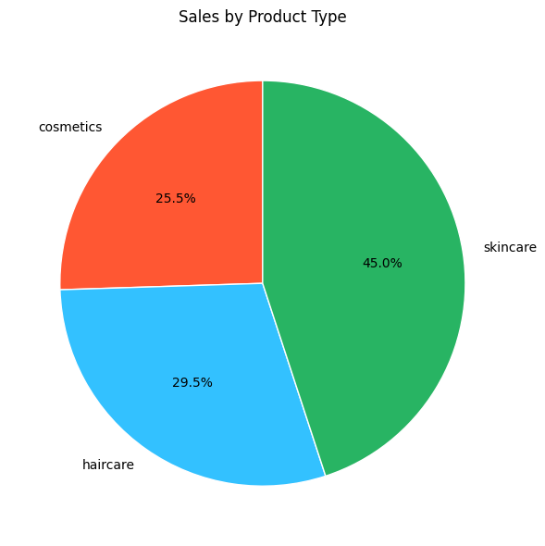
#Analyze the Revenue Generated by each SKU
total_revenue=df.groupby('Shipping carriers')['Revenue generated'].sum().reset_index()
total_revenue
Shipping carriers Revenue generated
0 Carrier A 142629.994607
1 Carrier B 250094.646988
2 Carrier C 184880.177143
import matplotlib.pyplot as plt
# Bar chart: Total Revenue by Shipping Carriers
plt.figure(figsize=(10, 6))
plt.bar(
total_revenue["Shipping carriers"],
total_revenue["Revenue generated"],
color="#1f77b4", # Bold blue
edgecolor="black"
)
# Labels and title
plt.title("Total Revenue by Shipping Carriers")
plt.xlabel("Shipping Carriers")
plt.ylabel("Revenue Generated")
plt.xticks(rotation=45)
plt.tight_layout()
plt.show()
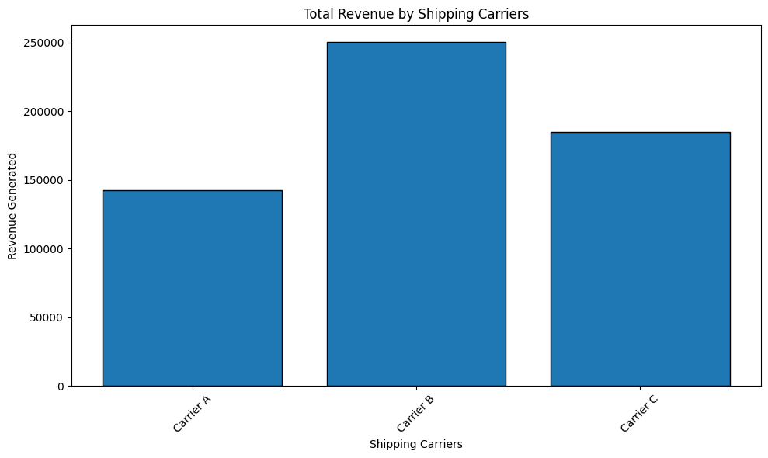
import matplotlib.pyplot as plt
# Line chart: Revenue by SKU
plt.figure(figsize=(10, 6))
plt.plot(
df["SKU"],
df["Revenue generated"],
marker="o",
linestyle="-",
color="#1f77b4"
)
# 🧾 Labels and title
plt.title("Revenue Generated by SKU")
plt.xlabel("SKU")
plt.ylabel("Revenue Generated")
plt.xticks(rotation=60, ha="right")
plt.xticks(df["SKU"][::5])
plt.tight_layout()
plt.show()
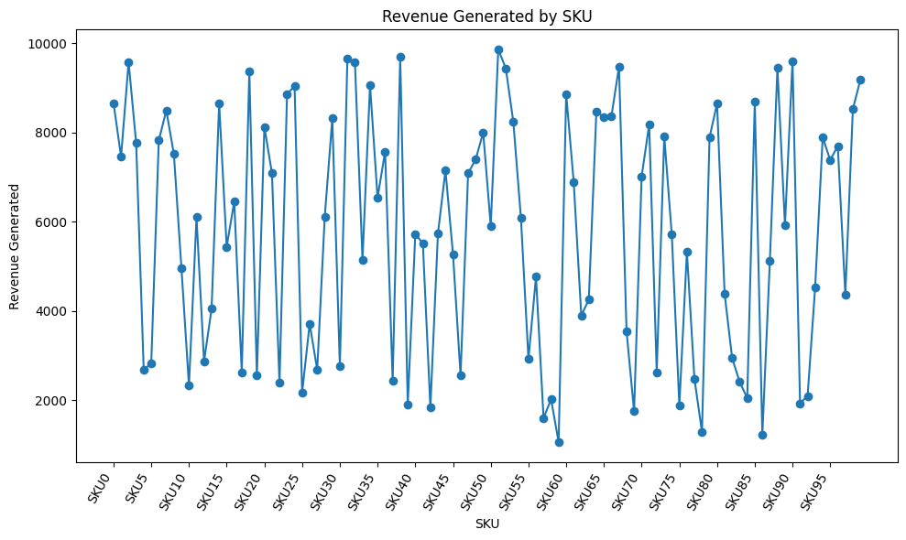
import matplotlib.pyplot as plt
# Bar chart: Order Quantity by SKU
plt.figure(figsize=(12, 6))
plt.bar(
df["SKU"],
df["Order quantities"],
color="#2ca02c",
edgecolor="black"
)
# 🧾 Labels and title
plt.title("Order Quantity by SKU")
plt.xlabel("SKU")
plt.ylabel("Order Quantities")
plt.xticks(rotation=60, ha="right")
plt.xticks(df["SKU"][::5])
plt.tight_layout()
plt.show()
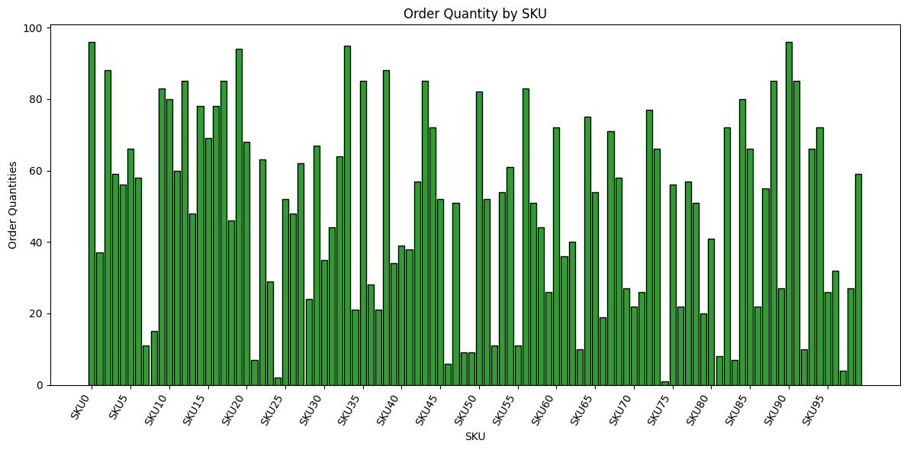
import matplotlib.pyplot as plt
#Bar chart: Shipping Costs by Carrier
plt.figure(figsize=(10, 6))
plt.bar(
df["Shipping carriers"],
df["Shipping costs"],
color="#27d6b0",
edgecolor="black"
)
# 🧾 Labels and title
plt.title("Shipping Costs by Carrier")
plt.xlabel("Shipping Carriers")
plt.ylabel("Shipping Costs")
plt.xticks(rotation=45, ha="right")
plt.tight_layout()
plt.show()
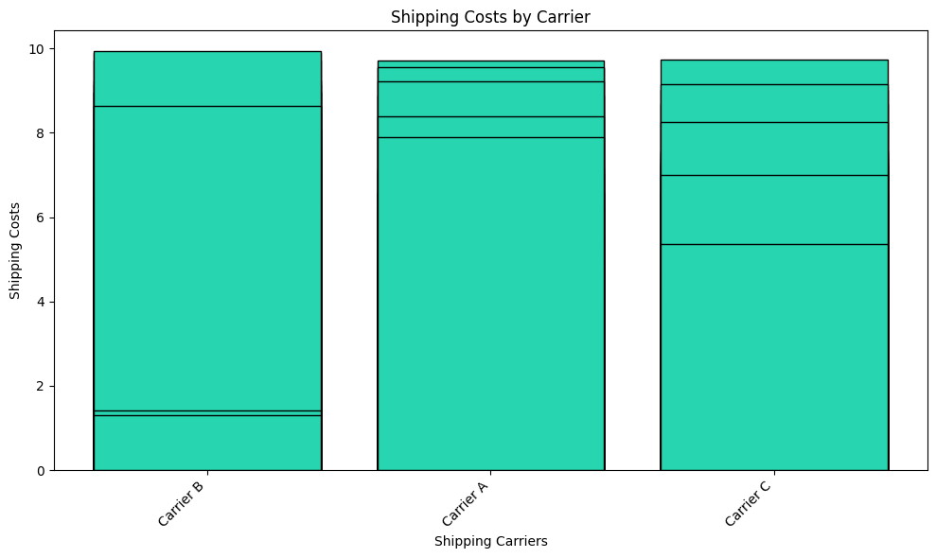
import matplotlib.pyplot as plt
#Aggregate costs by transportation mode
cost_summary = df.groupby("Transportation modes")["Costs"].sum()
#Bold color palette
bold_colors = ["#FF5733", "#33C1FF", "#28B463", "#AF7AC5", "#F4D03F", "#E67E22"]
#Pie chart
plt.figure(figsize=(8, 6))
plt.pie(
cost_summary,
labels=cost_summary.index,
autopct="%1.1f%%",
startangle=90,
colors=bold_colors[:len(cost_summary)],
wedgeprops={"edgecolor": "white"}
)
plt.title("Cost Distribution by Transportation Mode")
plt.tight_layout()
plt.show()
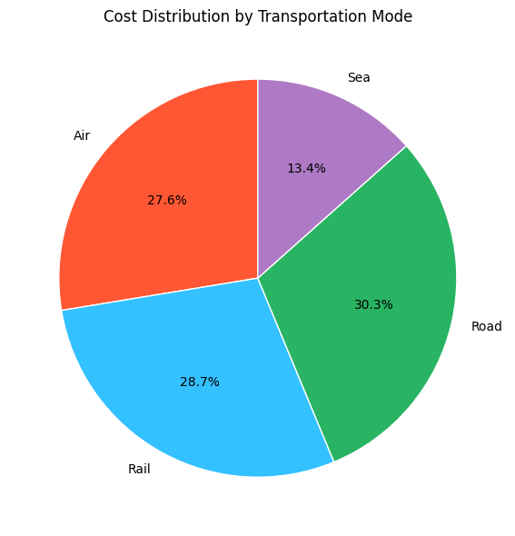
df.columns = df.columns.str.strip()
import matplotlib.pyplot as plt
import seaborn as sns
plt.figure(figsize=(10,4))
sns.boxplot(
data=df,
x="Product type",
y="Number of products sold"
)
plt.title("Demand by product type")
plt.tight_layout()
plt.figure(figsize=(10,4))
sns.boxplot(
data=df,
x="Location",
y="Number of products sold"
)
plt.title("Demand by location")
plt.tight_layout()
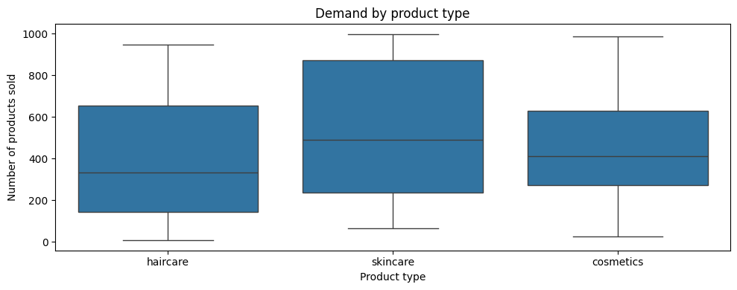
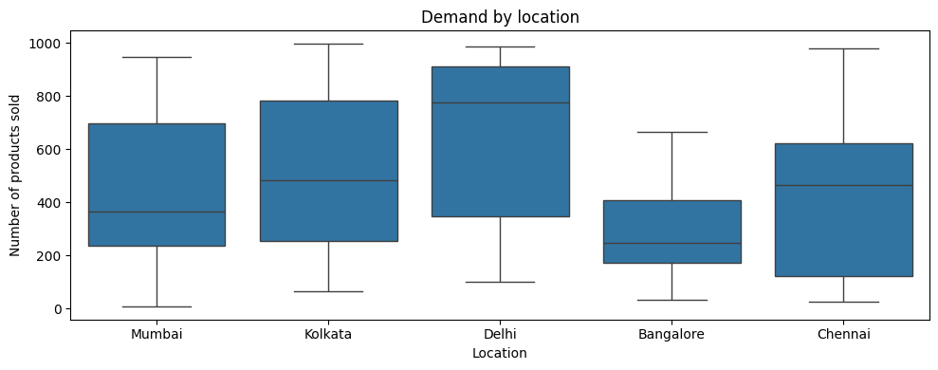
df.columns
Index(['Product type', 'SKU', 'Price', 'Availability',
'Number of products sold', 'Revenue generated', 'Customer demographics',
'Stock levels', 'Lead times', 'Order quantities', 'Shipping times',
'Shipping carriers', 'Shipping costs', 'Supplier name', 'Location',
'Lead time', 'Production volumes', 'Manufacturing lead time',
'Manufacturing costs', 'Inspection results', 'Defect rates',
'Transportation modes', 'Routes', 'Costs'],
dtype='object')
# Target distribution
plt.figure(figsize=(6,4))
sns.histplot(df['Number of products sold'], bins=50, kde=True)
plt.title("Demand distribution (Number of products sold)")
plt.tight_layout()
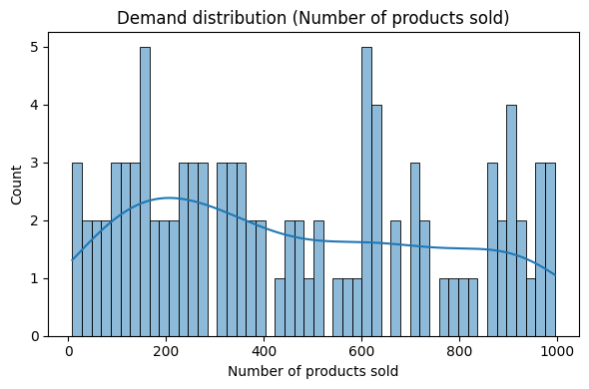
import matplotlib.pyplot as plt
import seaborn as sns
# Compute corr on numeric columns only
corr = df.corr(numeric_only=True)
plt.figure(figsize=(8,6))
sns.heatmap(corr, annot=True, fmt=".2f", cmap="coolwarm")
plt.title("Numeric Correlation Heatmap")
plt.tight_layout()
plt.show()
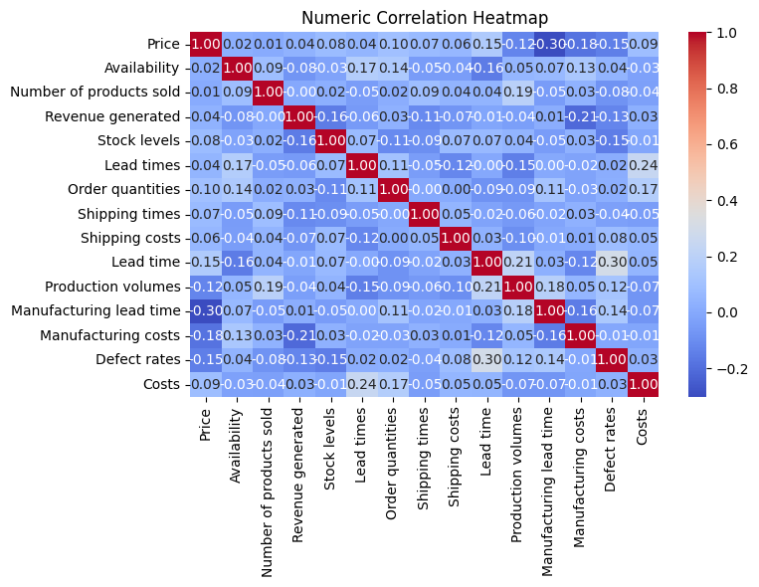
#The heatmap confirms that your primary demand-driving variables are Price, Availability/Stock and Lead time, which will be critical features in your forecasting model.
# Select features and target
features = [
"Price", "Availability", "Order quantities", "Stock levels",
"Lead times", "Shipping costs", "Production volumes",
"Manufacturing costs", "Defect rates"
]
target = "Number of products sold"
# Prepare X and y
X = df[features]
y = df[target]
# Train-test split
from sklearn.model_selection import train_test_split
X_train, X_test, y_train, y_test = train_test_split(X, y, test_size=0.2, random_state=42)
#model training
from sklearn.ensemble import RandomForestRegressor
# Initialize and train model
model = RandomForestRegressor(n_estimators=100, random_state=42)
model.fit(X_train, y_train)
RandomForestRegressor(random_state=42)
#Model evaluation
from sklearn.metrics import mean_absolute_error, mean_squared_error, r2_score
# Predict
y_pred = model.predict(X_test)
# Evaluate
mae = mean_absolute_error(y_test, y_pred)
rmse = np.sqrt(mean_squared_error(y_test, y_pred))
r2 = r2_score(y_test, y_pred)
print(f"MAE: {mae:.2f}")
print(f"RMSE: {rmse:.2f}")
print(f"R² Score: {r2:.2f}")
MAE: 310.46
RMSE: 354.84
R² Score: -0.32
#Model deployment
import joblib
# Save model
joblib.dump(model, "supply_chain_sales_model.pkl")
# Load model
loaded_model = joblib.load("supply_chain_sales_model.pkl")
# Predict with loaded model
new_predictions = loaded_model.predict(X_test)
import matplotlib.pyplot as plt
import seaborn as sns
# Feature importance
importances = model.feature_importances_
feature_names = X.columns
# Plot
plt.figure(figsize=(10, 6))
sns.barplot(x=importances, y=feature_names, palette="viridis")
plt.title("Feature Importance")
plt.xlabel("Importance Score")
plt.tight_layout()
plt.show()
C:\Users\Lenovo\AppData\Local\Temp\ipykernel_21808\3294708367.py:10: FutureWarning:
Passing `palette` without assigning `hue` is deprecated and will be removed in v0.14.0. Assign the `y` variable to `hue` and set `legend=False` for the same effect.
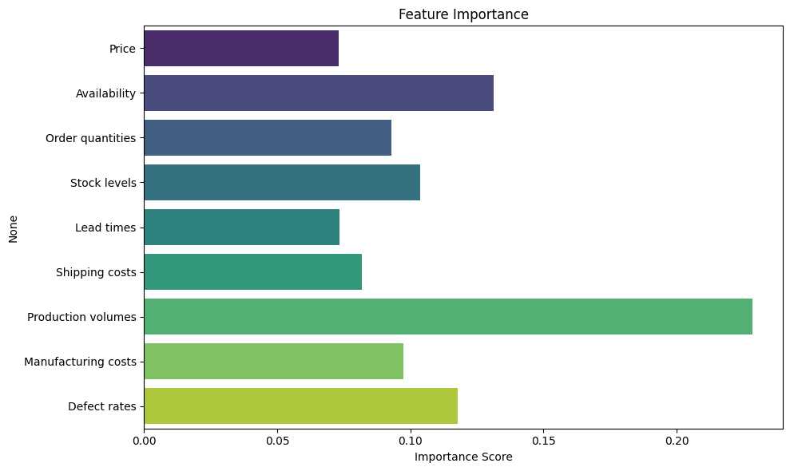

Conclusion
This project provided hands-on experience in data cleaning, visualization, and machine learning. It highlighted key supply chain inefficiencies and offered a foundation for predictive analytics. Future work will focus on improving model accuracy and integrating insights into decision-making tools.

